


2023 Kingsley Excellence

Award Winner


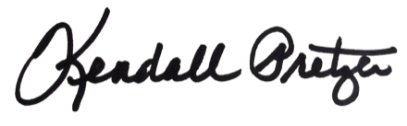
Your Company Name Here

© 2023 Grace Hill, Inc. All rights reserved.
Kendall Pretzer
Chief Executive Officer
Grace Hill
for its achievement in exceeding the Kingsley Index™ industry benchmark for overall tenant satisfaction and going above and beyond to guarantee that tenants are satisfied with their experience.

This certificate is presented to:
© 2021 Grace Hill, Inc. All rights reserved.

