


2026 Kingsley Excellence Award

Award Winning Company


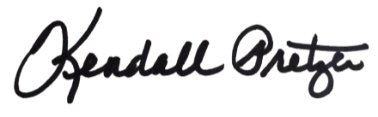

This certificate is presented to:
Your Company Name Here

Kendall Pretzer
Chief Executive Officer
Grace Hill
or its achievement in outperforming the Kingsley Index™ benchmark for overall tenant satisfaction. This award recognizes individual commercial properties that set the industry standard by delivering a superior level of service and excellence to their tenants.
© 2021 Grace Hill, Inc. All rights reserved.
© 2026 Grace Hill, Inc. All rights reserved.

