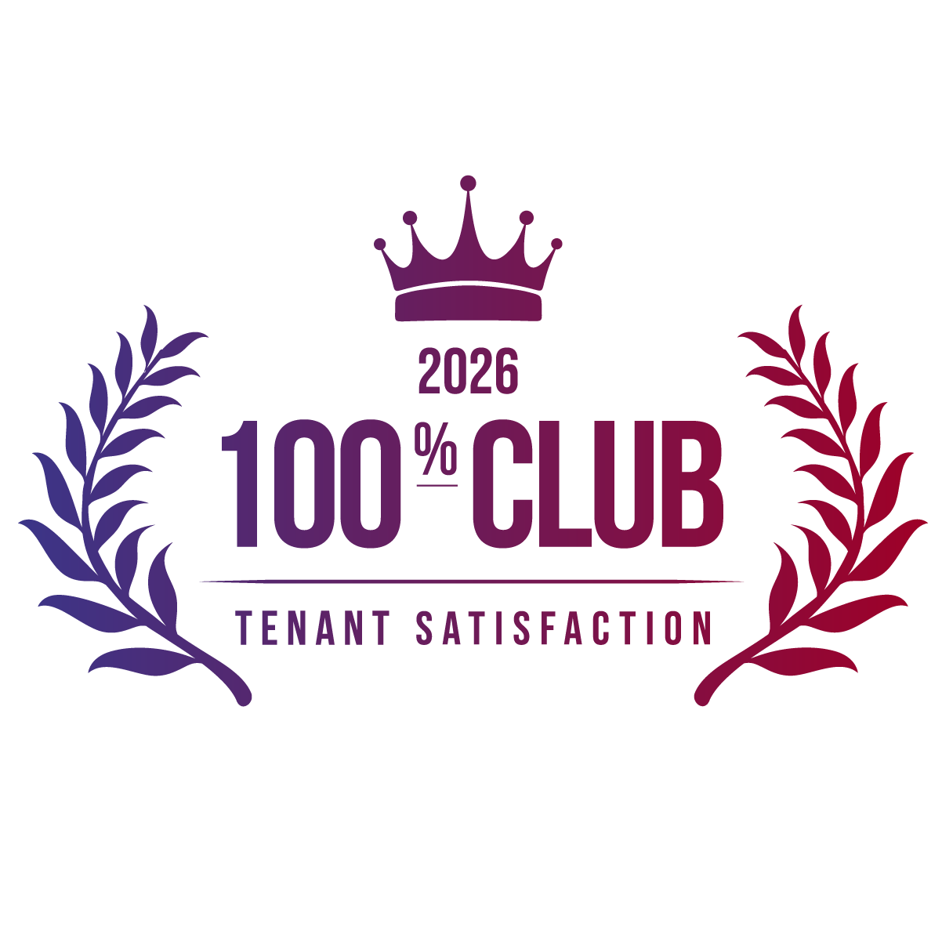


2026 Kingsley Excellence Award

100% Club Designation


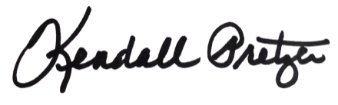

This certificate is presented to:
Your Company Name Here

Kendall Pretzer
Chief Executive Officer
Grace Hill
for its achievement in earning a perfect 5.0 overall tenant satisfaction score for two consecutive years. This designation honors properties that have reached the ultimate peak of the Kingsley Index™, maintaining an uncompromising 100% satisfaction rating through consistent and dedicated performance.
© 2021 Grace Hill, Inc. All rights reserved.
© 2026 Grace Hill, Inc. All rights reserved.

