


2026 Kingsley Excellence Award

Elite 5 Designtaion


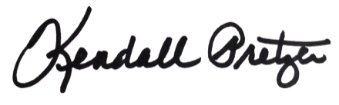

This certificate is presented to:
Your Company Name Here

Kendall Pretzer
Chief Executive Officer
Grace Hill
for its achievement in ranking as one of the top five commercial real estate organizations in their sector for overall tenant satisfaction. Representing the highest honor within the Kingsley Index™, the Elite 5 designation recognizes the industry’s most elite portfolios that have demonstrated unparalleled leadership in tenant experience across their entire organization.
© 2021 Grace Hill, Inc. All rights reserved.
© 2026 Grace Hill, Inc. All rights reserved.

