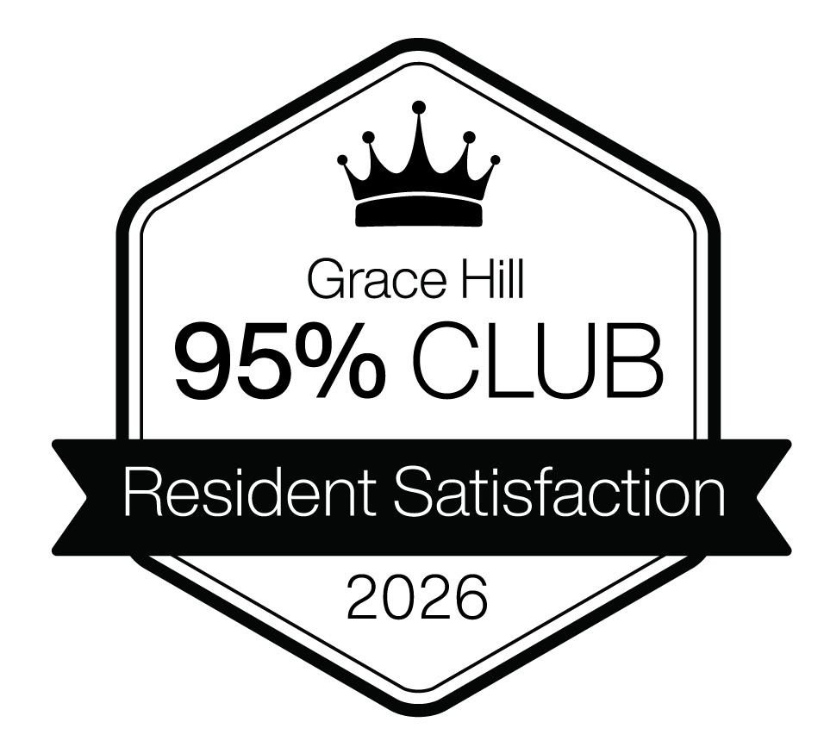


2026 Grace Hill Excellence Award

95% Club Designation


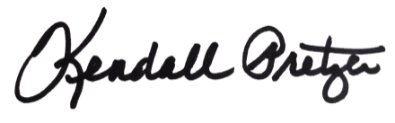

This certificate is presented to:
Your Company Name Here

Kendall Pretzer
Chief Executive Officer
Grace Hill
for its achievement in ranking among the top 5% of properties across the Kingsley Index™. This prestigious honor recognizes an elite level of resident satisfaction, placing this community in the highest tier of performance and third-party validation from Grace Hill survey programs.
© 2021 Grace Hill, Inc. All rights reserved.
© 2026 Grace Hill, Inc. All rights reserved.

