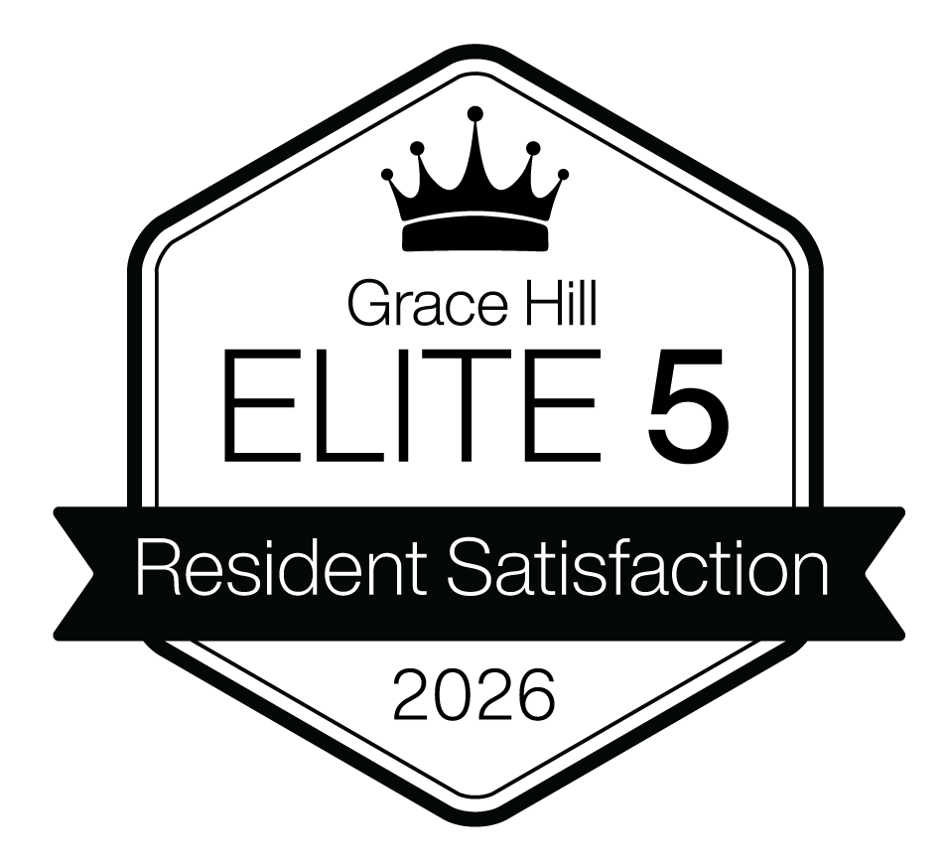


2026 Grace Hill Excellence Award

Elite 5 Designation


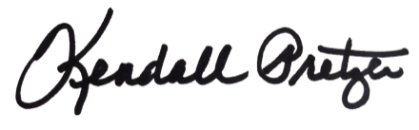

This certificate is presented to:
Your Company Name Here

Kendall Pretzer
Chief Executive Officer
Grace Hill
for its achievement in being named one of the five top-performing multifamily companies in the nation for overall resident satisfaction. As the most prestigious designation in the Kingsley Index™, the Elite 5 represents the absolute pinnacle of customer service and performance benchmarking across the entire multifamily sector.
© 2021 Grace Hill, Inc. All rights reserved.
© 2026 Grace Hill, Inc. All rights reserved.

