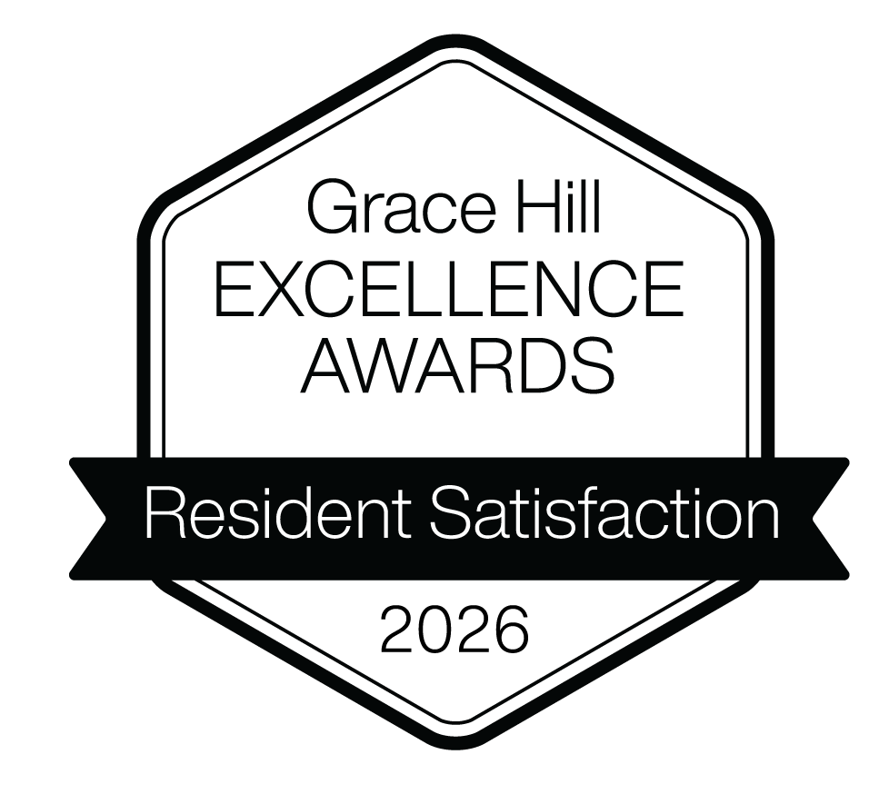


2026 Grace Hill Excellence Award

Award Winning Company


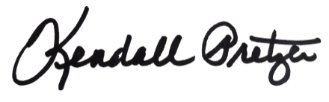

This certificate is presented to:
Your Company Name Here

Kendall Pretzer
Chief Executive Officer
Grace Hill
for its achievement in exceeding the Kingsley Index™ industry benchmark for overall resident satisfaction. This designation honors properties that have gone above and beyond to deliver an exceptional living experience that outperforms the standard for excellence in the multifamily industry.
© 2021 Grace Hill, Inc. All rights reserved.
© 2026 Grace Hill, Inc. All rights reserved.

